St. Vincent Mission
Volunteer Program

Why we want you to be a volunteer with us:
God has gifted each of us differently. We use those gifts for His glory. Volunteers bring unique gifts and perspectives to our team. They also bring with them a passion for the service that renews our focus. We want to give young people the opportunity to serve Christ and see the work that He is doing through others in Appalachia. We hope that each intern will grow in their walk with Christ while they are here and gain perspective on their gifts and calling.

Why should I become a volunteer with St. Vincent Mission?
Deuteronomy 15:7-8
“If there is among you a poor man of your brethren, within any of the gates in your land which the Lord your God is giving you, you shall not harden your heart nor shut your hand from your poor brother, but you shall open your hand wide to him and willingly lend him sufficient for his need, whatever he needs.”
Service with St. Vincent Mission because you have a desire to serve God and bring Him glory.
St. Vincent Mission provides our program participants the opportunity to help themselves come out of poverty. Our programs require the participants to do work for the services that they receive. This helps them to develop skills and gives them a feeling of accomplishment. We desire to help people come out of poverty not merely support them while they are in it.

What to expect:
Accommodations: Volunteer Housing. Depending on the number of volunteers we have, each volunteer will have their own room.
Stipend: $200 a month
Community: Christ focused community.

How Do I become a Volunteer?
Apply
Please send the following items through email to erin@stvincentmission.org:
1. Cover letter describing why you want this opportunity and how you are qualified to meet the volunteer requirements
2. Letter of recommendation from a professor, dean or instructor of school attending
3. Send Copy of your Driver’s License or ID.

Spring Semester Volunteer
January - April
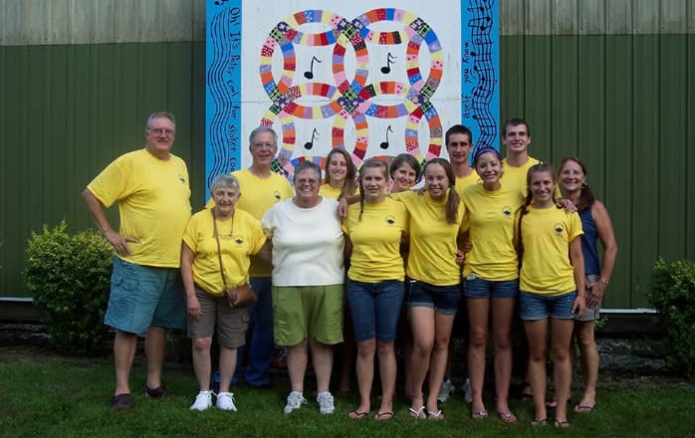

Service areas:
- Provide administrative assistance and program outreach for all programs and activities, including home repairs and sustainable agriculture
- Update spreadsheets and databases for donors, media and partnerships
- Assist with spring appeal mailings
- Network through social media for greater program awareness
- Network with other agencies for better meet participant needs
- Research opportunities for submitting grant proposals to develop and expand St. Vincent services and outreach programs
- Develop relationships with program participants to better meet their physical and spiritual needs while working with them, not for them
- Perform other duties as assigned, based on volunteer interest and agency priorities

General Requirements:
- Ability to work independently and with diverse populations
- Excellent oral and written communication skills
- Computer literate, possessing proficiency in Microsoft Word and basic Internet navigation abilities, especially with social media outlets; knowledge of Excel helpful but not required
- Dependability, reliability and extremely efficient follow-up skills is a must

Work Schedule:
Flexible and tailored, depending on school schedule, ranging from 20-35 hours per week

Summer Volunteer
May – August

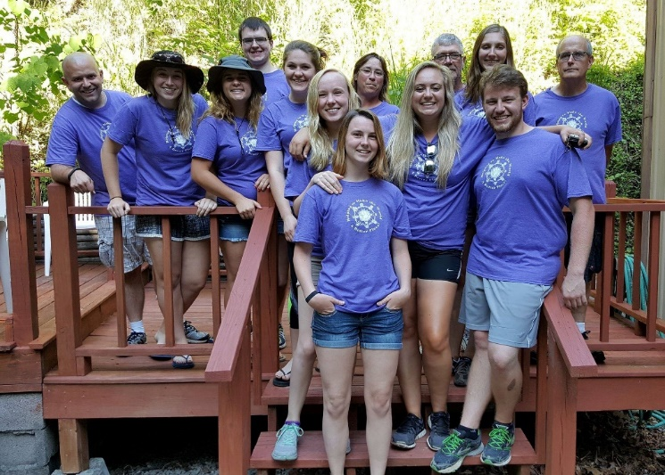

Service areas:
- Assist executive director in managing summer volunteer program
- Assist Home Repair Crew Leader and Community Support Director
- Provide administrative assistance to the Executive Director for the home repair program and other St. Vincent activities
- Work with volunteer groups as a crew leader for the home repair program
•Develop relationships with program participants to better meet their physical and spiritual needs while working with them, not for them
- Update spreadsheets and database for donors and funders, media contacts, volunteers and partnerships
- Assist with mailings and social media networking
- Research opportunities for submitting grant proposals to develop and expand St. Vincent services and outreach programs
- Perform other duties as assigned, based on intern interest and agency priorities.

General Requirements:
- Ability to work well in a fast paced, changing environment
- Excellent oral and written communication skills
- Computer literate, possessing basic Internet navigation abilities, including social media outlets, and proficiencies in Microsoft Office
- Have regular and consistent computer access, including the ability to work online
- Dependability and Reliability including good follow-up skills

Work Schedule
Flexible and tailored, depending on school schedule; ranging from 15-35 hours per week

Fall Volunteer
September - December

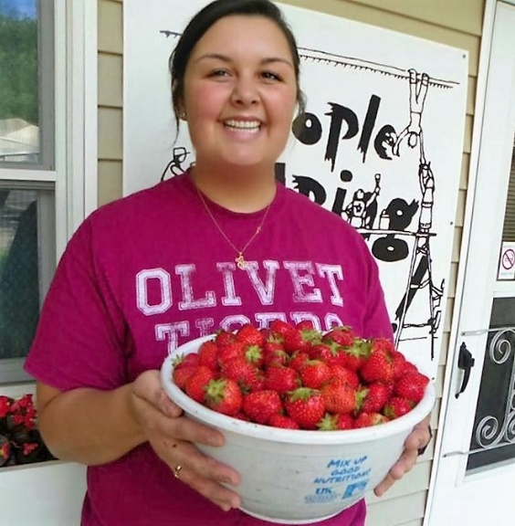

Service Areas:
- Assist executive director and Social Service Director as needed
- Provide administrative assistance to program coordinators for fall program activities, including planning and organizing the family fun day and the annual Christmas store.
- Develop relationships with program participants to better meet their physical and spiritual needs while working with them, not for them
- Update spreadsheets and database for donors and funders, media contacts, volunteers and partnerships
- Assist with fall appeal mailings and social media networking
- Research opportunities for submitting grant proposals to develop and expand St. Vincent services and outreach programs
- Perform other duties as assigned, based on intern interest and agency priorities

General Requirements:
- Ability to work well in a fast paced, changing environment
- Excellent oral and written communication skills
- Computer literate, possessing basic Internet navigation abilities, including social media outlets, and proficiencies in Microsoft Office
- Have regular and consistent computer access, including the ability to work online
- Dependability and Reliability including good follow-up skills

Work Schedule
Flexible and tailored, depending on school schedule; ranging from 15-35 hours per week

