St. Vincent Mission
Volunteer Guide

6369 State Highway 404
David, KY 41616
606-886-2513
www.stvincentmission.org
Erin@stvincentmission.org

Table of Contents
Who We Are…………………………………………………….…….3-4
Our Programs………………………………………………….………5-8
Volunteer House…………………………………………………......9-10
Information you Need to Know Before Your Visit………………...11-12
What does a week in the life of a volunteer look like?...........................13
Safety Measures While on the Job………………………………….14-16
How do We Get Materials?...................................................17-18
Phone Numbers……………………………………………………..19-20

Who We Are
St. Vincent Mission is a community of people in Appalachia dedicated to sharing the expression of Christian Values. We believe that all persons have a God-ordained right to the basic needs of life in order to meet their full potential. This is accomplished through concrete programs that encourage discovery, development and use of our personal gifts.
Our Mission is one of HOPE that leads us toward a vision of continuous growth.
Our priorities are to show our community the Love of Christ by helping them bring themselves out of poverty. We do this by:
- Offering programs that include those we serve as the solution to their current challenges.
- Providing work opportunities and education to those seeking employment.
- Encouraging sustainable living through wise spending, gardening and self-help.

History

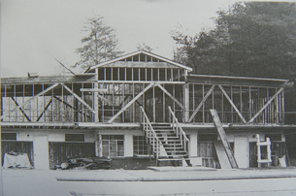
In 1968 the Brothers of Charity from Philadelphia began a social service program in Floyd County, Ky. They joined Father William Poole who had just been appointed pastor. The Brothers moved to Martin, Ky. in June, 1968. They took over a building that had been used by the Sisters of Divine Providence as a grade school.
In 1970 the Brothers found a property for sale in the old coal mining town of David, KY. St. Vincent Mission moved to that property and began serving the residence of that town. The number of volunteers and programs grew rapidly. The Mission began doing social work county wide including the county's first food pantry, home improvements and a child care center. The Mission also started a sewing and crafts program for women and held weekend youth programs and dancing classes, Bible School and helped revive the Boy Scout program.
The town of David had been purchased from the coal company by a man named Woodrow Branham. The town had deteriorated pretty quickly. The concept of a Community Development Corporation began to be discussed as a way for the town to revive itself. In 1972 the idea began to take a more concrete shape and in 1974 we entered an agreement to buy the town of David. The David Community Development Corporation became a reality. The people of the town were organized into a board of Directors and in 1975 the purchase was made. The loan package was seed money from the Brothers of Charity, a Washington group, and the local bank.
Now the mission continues its service in the town of David. Programs have adapted and changed with the needs of our community. Building on our rich history of faith, volunteerism and service- we continue to serve God in our service to those in need in our community.
Good Reads
- “When Helping Hurts” by Steve Corbett & Brian Fikkert
- “Helping without Hurting in Short Term Missions” by Steve Corbett & Brian Fikkert
- “Uneven Ground: Appalachia Since 1945” by Ronald Eller

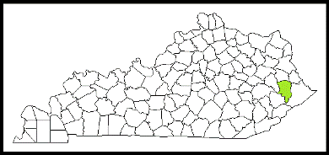
Our Service Area

Floyd County-Population 35,589

Floyd County Statistics compared to total U.S | Floyd County | Total U.S
Percent with HS Edu. | 73.8 % | 87.7 %
Percent with BA Degree | 11.25 % | 31.5 %
Percent with Disability | 22.6 % | 8.6 %
Percent in Labor Force | 40 % | 62.9 %
Median Household Income | $31,267 | $60,293
Poverty Rate | 34.2 % | 11.8 %

As you can see from the chart above Floyd County Kentucky has a lower rate of High School graduates, individuals with a BA degree and individuals in the work force. We also have a higher rate of disability and poverty than the national average. Our household income is $29,026 less than the national median income.

How We Serve Well

Our approach to poverty alleviation is holistic. We do not believe that lack of resources is the only thing that leads to poverty. Broken systems, broken regions and broken people all lead to poverty.

Broken Systems: Organizations that endeavor to alleviate poverty by giving handouts without addressing the core issues of poverty. An example would be the cut off for Social Security benefits and foods stamps the moment someone gets a job. This provides no grace period to adjust to the new income, which may encourage families to quit the newly-earned job.

Broken Regions: We have bad roads, isolated areas and people with limited transportation. This leads to less job opportunities. We also have limited job options due to the lack of industry.

Broken People: People often succumb to patterns of generational poverty, wrong thinking about money and priorities in their spending habits that are not in line with proper budgeting.

We may get a call from someone who needs help with paying an electric bill, but their real need is a job or money management assistance. Both of those we are able to help with, but the real need is not always evident. This is one reason we have for requiring people to volunteer after assistance. The other reason is that we want people to be empowered to provide for themselves. Handouts produce dependence. We do not want people to think that the best they can do is beg for help. We empower them with opportunities rather than give them handouts.

Poverty alleviation has to combat all the reasons why someone is living in poverty. It is not merely a lack of material resources. We serve the way that we do because we want to see a long-term change in peoples live. Handouts don’t produce long term change. We want to walk with people long term to see them come out of poverty and not need governmental or non-profit assistance, so that they might have the pride of providing for their families themselves.

Our Programs
Home Repair
We help families with room additions, roofs, ramps, decks, foundation issues, floor damage, drywall and other repairs.
Volunteers work alongside home owners to help them make the repairs on their own homes. Home owners are fully involved in the process from the beginning. They decide what repairs are the most important and they pay a part of the materials cost. Often times home owners will prepare meals for the volunteers as a token of their appreciation. More important than the home repairs are the relationships that are built between home owner & volunteer. Volunteers learn from the home owners and leave Kentucky with a better understanding of our way of life, Appalachian values and our beautiful, wise and creative residents.
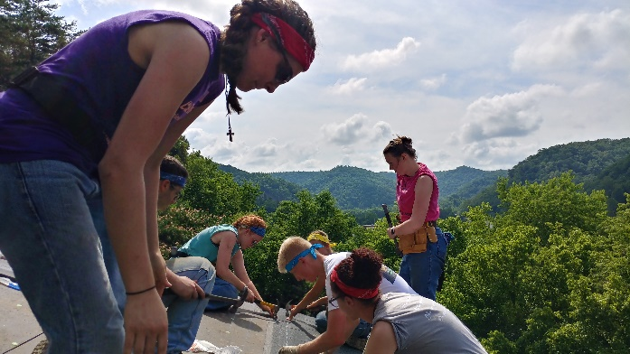
Why do we require home owners to help and to pay part of the material cost?
- When you are invested in something you take care of it.
- Many people do not like to ask for help, but when they are a part of the work and pay for part of the material cost they are able to have pride in the work and in their ability to take care of their home.
- When home owners and volunteers work together they learn from each other and build relationships.

The results of our wonderful and dedicated volunteer groups

In 2023, 42 homes received repairs at a cost of $51,786 for materials. 231 volunteers provided 7,632 hours of service, and volunteers and home owners were forever changed by each other’s kindness, grace and compassion.

Grow Appalachia

Our garden program exists to help people live more sustainable and healthy lives. The Appalachian region has a strong history of farming and self-sustainable living. What we wish to do with this program is to help families get back to those roots. With our high food insecurity rate, it has become necessary for families to grow gardens.

What we do:
Teach courses on: sustainable gardening, organic pest control, organic weed control, canning and other forms of food preservation. We teach class once a month during the growing season.

Food Pantry

What we do:
St. Vincent Mission operates a food pantry that is open on Tuesday to our local community. Families are able to come into our food pantry and pick out the food that they would like. They are given a certain number of food items that they are able to get. We let individuals to choose what they want so that they get the items that they actually need for their families.

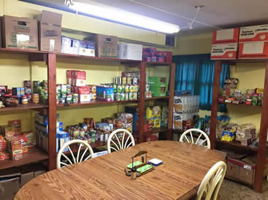
What we provide:
- Government Commodities- canned food, meat, dairy and frozen food
- Donated and purchased food-boxed and canned items, drinks, meat, prepackaged food from our local grocery store
- Garden produce from our mission garden and other sources
- Personal care item such as toilet paper, dish washing liquid, laundry detergent, etc.

Community Events

Classes that we Teach:
We offer classes on: healthy, budget and diabetic cooking, crafting, pet care, financial education, work/career skills, maintaining and winterizing your home, seed starting, garden bugs, food preservation, self-defense, advocating for your child and personal health and wellness.

Family Fun Days:
We host several family events such as:
- Easter Egg Hunt
- Out of School Celebration
- Day Camp
- Back Pack Give Away
- Fall Festival

Scholarships

Who we help
- Residents of Floyd County and the surrounding counties
- Low income individuals

What we help with
- We help with up to $500 per semester
- College/trade tuition
- Books, uniforms, nursing items, trade items, etc.

Thrift Store
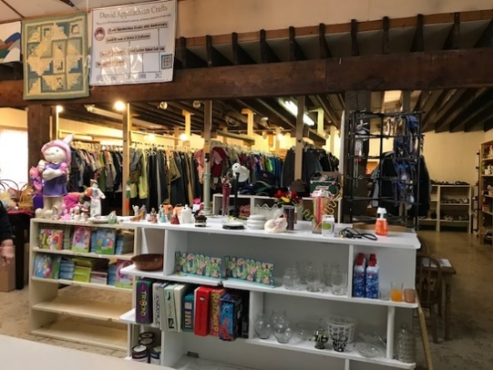
What we do
Our thrift store is open to the public Monday – Friday, 9am to 3pm. We sell clothes, shoes, furniture, household items and toys at a low cost. Often times, when people come to our Food Pantry, they will shop in the thrift store. This gives people the opportunity to socialize with each other and with staff members. It doesn’t seem like much, but when you only leave home a few times a month, having the opportunity to talk and spend time with others can be very important.

Flood, Fire and other Natural Disasters
Sometime people come to the mission who have lost possessions to fire, flood, theft and other situations. People also sometimes need clothes for school, job interviews or specific clothes for work who are unable to purchase them. We provide clothes and household items for free to those who have had some sort of natural disaster. If someone is struggling financially and just needs a little extra help, we ask that they do volunteer work to pay for what they need. Many times, people will work for furniture or other household items that they might need.

Emergency Assistance

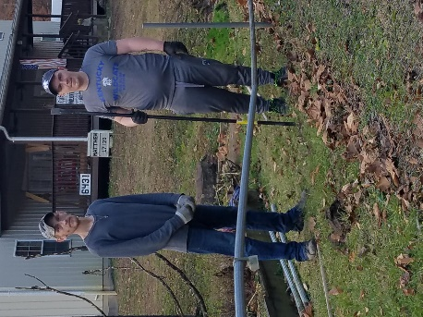
What we help with:
We assist families with electric, water, insurance, gas cards for medical care, and emergency hotel rooms. Families are able to access assistance once a year. Typically, we pay between $50 and $200 on a bill.
Some of the recipients are elderly, disabled, families with several children, individuals coming out of a domestic violence situation, and people who have had an unexpected financial burden.
What they do in return:
We ask that when we assist a family with a bill, that a member of the family come volunteer at the mission for 6 hours per $100. Many of the people we serve come with different skills that they are able to use to help us.

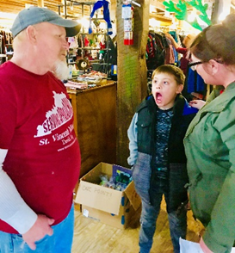
Christmas Program
What we do:
We provide families with the opportunity to “shop” in our Christmas store. They use points to shop and are able to get items for themselves and their family for Christmas. We have household items, clothes and toys. They also receive hygiene products, a food gift cards and stocking stuffer items.
Who we help:
- We help families who have accessed our services throughout the year such as: Home Repair, Emergency Assistance & Career Readiness.
- Other organizations: Women’s Drug Rehab, a non-profit who serves adults with special needs & chronically homeless people, Fire Departments, Nursing Homes and pre-school classes

Career Readiness Internships

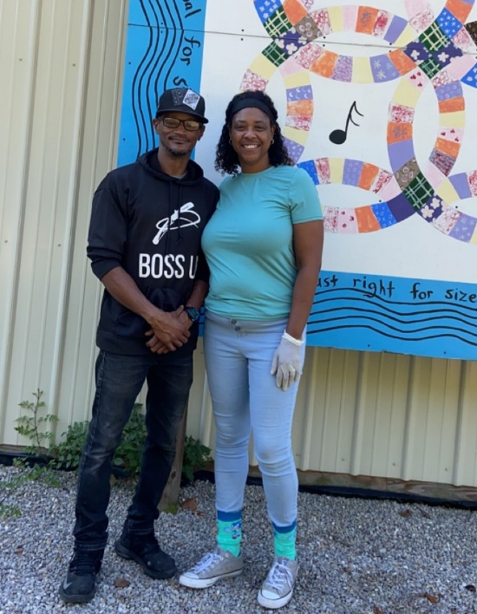
What we do
We offer a faith-based course called "Work Life”. This course teaches how to write a resume & cover letter, soft skills, conflict resolution, overcoming obstacles to employment and how to navigate the work place to be an effective employee.
While on our program, they work at the mission for 2 days a week at minimum wage. Our program lasts 3 to 4 months and we want them to have a permanent job at the end of their program participation. We also provide support while they seek a job. Examples of this include letting them know about jobs in the area, helping with applications and practice interviews.

What they do
Interns work in the Home Repair Program, Woodworking, Garden Program, Thrift Store, Food Pantry, Emergency Assistance and Technical Support. This gives them the opportunity to learn a skill that can be used at a job or that they can use themselves to make extra income or provide for their needs (such as gardening, woodworking or repairing their own home to save money).
They work alongside employees learning these skills. The employee they work with also teaches them basics principals to being a good employee and works with them on the concepts learned in the work life class.
Your volunteer group might be partnered up with one of our interns during your week of volunteer service.

Why Do We Do This?
Many people we serve through this program have a criminal history, past drug addiction, have never worked a job or they just don’t know how to be a good employee. These are all barriers to employment. Our goal is to train people to be good employees, give opportunities to those with past bad behavior and offer an opportunity where there would not otherwise be one.
Getting a positive recommendation from us might breach the barrier of a criminal history. Working with us as a first-time job might lay a positive foundation for future work. Overall, we hope to break barriers to employment in the lives of those we serve.

Volunteer House
Common Areas

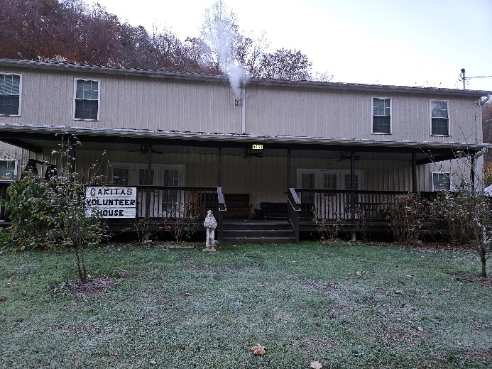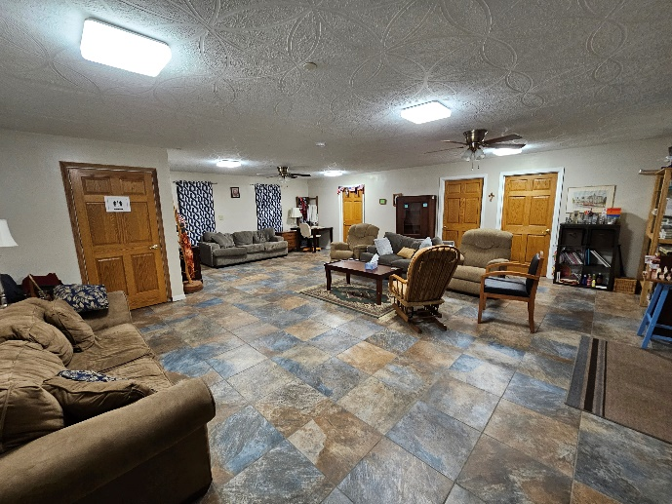

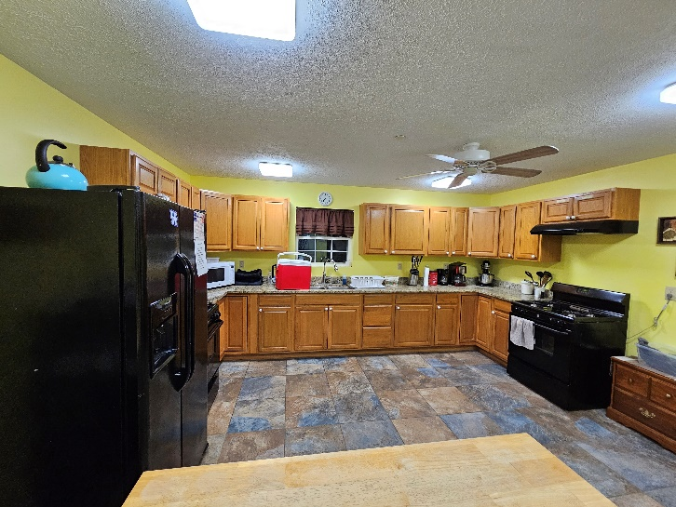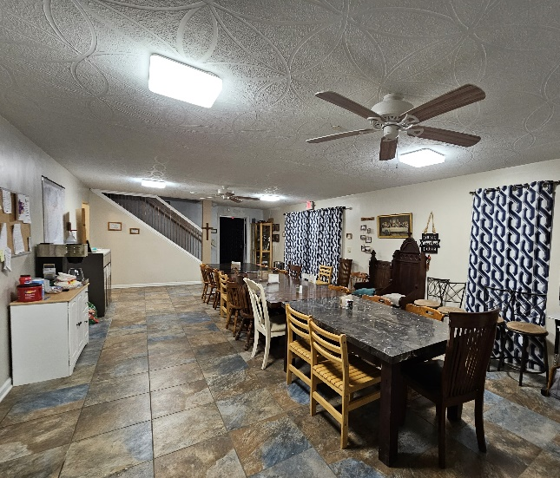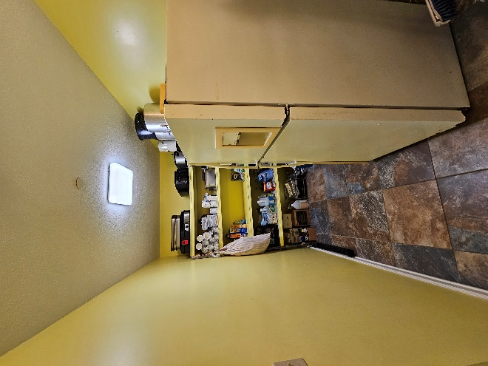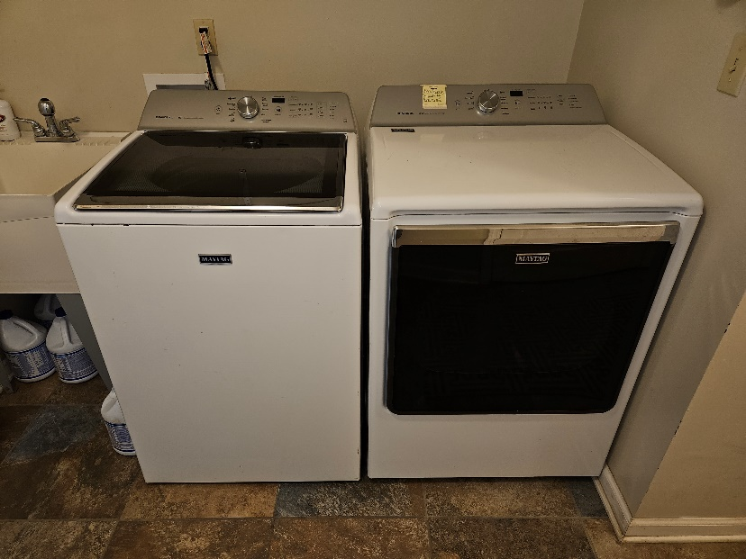

Down Stairs Bed Rooms
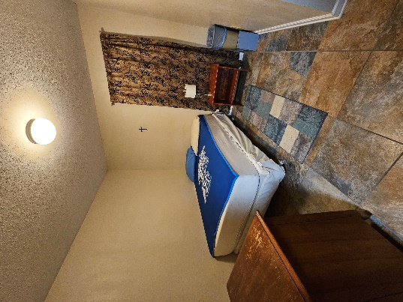
There are 3 bedrooms similar to this one. Typically 2 are available to volunteer group unless we have additional long term volunteers staying with us.

Upstairs Dorm Rooms

One has 5 bunkbeds for a total of 10 beds

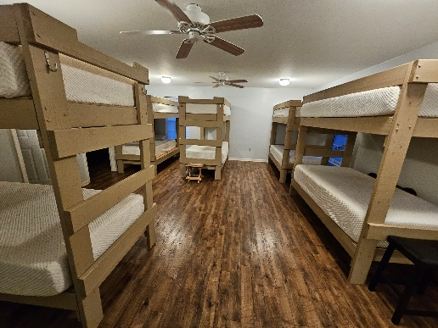

One hase 7 bunkbeds for a total of 14 beds
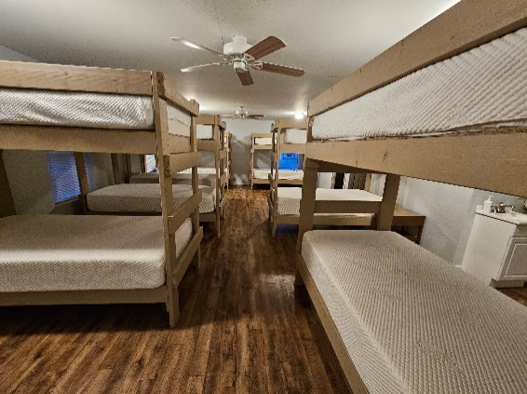

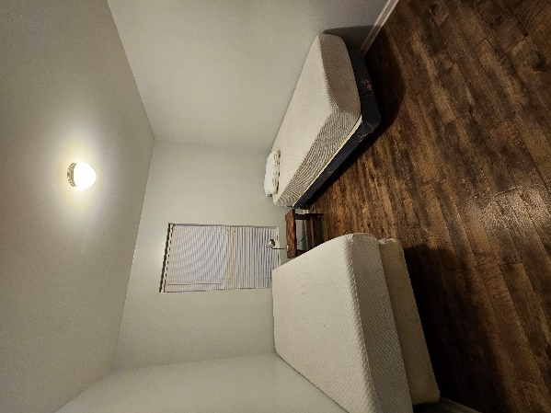
Each Dorm room has 2 individual bedrooms with 2 twin beds each in them, for a total of 4 twin beds in each dorm room for your adult leaders.

Information you Need to Know Before Your Visit

What is the Fee to come?
The cost per week is $300 per person.
If you are not coming for a full week the cost per person, per night is $60. (Ex. If you are coming for 2 nights the cost will be $120 per person)
Please send a $200 deposit with your registration form to secure your work week. The deposit will be credited to your account if you do not cancel. If you do cancel, your deposit will be used to support mission programs.
Who can volunteer and who should we bring?
Volunteers should be 13 or older.
Groups must provide adequate supervision of young people.
Skilled Volunteers: it is suggested that your group have one skilled person per seven students. By skilled we mean that they would be able to lead and direct their group on a work site. However, we understand that some groups do not have a skilled person to lead your team and we will plan accordingly. We will do our best to provide you with a skilled crew leader or give you a job that meets your skill level.
If you have people who want to come, but cannot do home repair work consider these options:
Bring someone who will cook for the group.
Bring someone to help our home repair crew leader deliver materials throughout the day.
Bring people who would like to: help in the garden program, work in our thrift store, deliver groceries or do home visits.

Goals for your volunteer week
- Live a life of service to God
- To serve our participants and show them the love of Christ through your actions and words.
- Practice good stewardship of all the resources entrusted to us.
- Leave here with an understanding of life in Appalachia and how you can continue to advocate and serve the Appalachian people.
- Pray for the work of the Mission to continue and to continue to glorify God through all that we do.

What to bring:
On top of your normal clothing and hygiene needs please bring:
Towel
Twin Blanket/sheets or sleeping bag
Pillow
Insect repellant and sunscreen
Closed toed shoes
Tools of your choosing

Our volunteer house has:
Pots and pans
Silverware
Plates, bowls and cups
Cooking utensils
Coffee pots
Food storage containers

Common tools you might want to bring if you have them:
Drills and impact drivers
Circular saw
Jig saw
Reciprocating saw
Hammers
Tape Measures
Squares
Goggles
Gloves

Things that are important to your work with us
1. Quality – When we work on a house or trailer, we work as if it were our own. Even if it is the worse place we have ever seen, we will do quality work. We never take the attitude, “well at least it is better than what they had before”. Be sure when using St. Vincent Mission equipment that you take care of everything. Return tools to their proper containers and place. Don’t wait for someone else to do it.
2. Homeowner Interaction – Even though we are coming to help make a situation better, we are still guests of the participant. It is important for the volunteers to talk with the home owners and get them involved in the process as much as they are able. We are not a “company” coming in doing repairs for a customer. One thing that is important to understand about this culture is that they do not want to disappoint you. Be sure you always ask the participant to work with you and allow them to help in every way.
3. Job Completion – We do our best to complete the job we have set out to do. Be sure to turn in all bills to the Home Repair Supervisor or appointee as you receive them. This also helps with paying the bills. Please only do the tasks assigned to your group. We cannot fix every problem on every home so we focus on the priorities. If you do more than assigned on one job another home owner may not get their home worked on.
4. Partnership– We are partners. You are not just some group coming in to do good. You are partners with St. Vincent Mission, the people you serve and those who helped to send you here. Be respectful in all that you do and say.

Guidelines and Code of Conduct
Prayer -There should be times set aside each day for prayer and reflection. Each person is expected to participate. Only through prayer and reflection will one have the strength and insight to benefit from the mission experiences.
Personal Growth and New Experiences - The Mission Volunteer Program is intended to provide help to people in need. It is intended to allow participants to become involved in the lives of those they serve, to become aware of the social and political problems they encounter, and to show the love of Christ to all who they are around.
Commitment – We are here to glorify God. In all that you do seek to Glorify Him and show the love of Christ to those you are around both on the job site and when you return to where you are staying. When you serve, seek the good of someone else and always focus on how you can help someone else. Your service here is not an experience, but a lifestyle that must continue long after you leave here.

What does a week in the life of a volunteer look like?
Sunday:
Arrival at the time of your choosing. Most groups try to get here around 6pm. Text Erin about an hour before you arrive. (606-339-0445) She will meet you at the volunteer house and go over the things you need to know. You will get your home owner book that will show you the jobs that you will work on during the week. If you will be working on more than one home, you will decide which of your adult leaders will lead the work crew and at which homes they will serve. In our experience it works best for you to have the same volunteers going out to the same homes each day. This allows for better relationship building with the home owners and lends itself to less confusion for your group.

Monday:
St. Vincent Missions Home Repair Crew Leader will meet with your group. He arrives at about 7 am. We ask that on the first day to the home that you will be working on, you arrive no earlier that 8am. After that, you may speak with the home owner and decided what time you will arrive going forward. Please make sure you properly communicate the time with your home owner. Also, if you will not be going out there the next day, please let the home owner know. A typical work day is 8am to 4pm, but you are free to adjust that time frame.
If the home owner asked you to do something that is not in the home owner book, you must get permission from the St. Vincent Mission Home Repair Crew Leader first. (606-339-8161)
At the end of your work day please make a list of the materials that you know you will need to finish the project and give or text it to the Home Repair Crew Leader.
Your meal times are up to you and your group.
Your lunch should be taken out to the work site with you, because many of our homes are at least 30 minutes away from the volunteer house.

Tuesday-Friday:
Make sure you keep your home owner informed as to what is going on with their repairs and when you will be coming out. Make sure that there are things the home owner can help you with and engage them in the repairs. This is very important – We want to work with the home owners not just for them. St. Vincent Mission partners with our home owners and they are expected to work alongside volunteers to accomplish their repairs. If you are offered food or drink, please gladly accept. The families we serve often love to share what they have and to provide meals for volunteer groups. The relationships forged around the kitchen table are some of the best examples of our cultural heritage.
If you feel like you will not be able to finish the all the different projects at an individual’s home, please only start the ones you will finish, unless you discuss it further with the Home Repair Crew Leader and get his ok to proceed.
At the end of your work day please make a list of the materials that you know you will need to finish the project and give or text it to the Home Repair Crew Leader.

On the last day of your volunteer week, please have each project that you started completed if possible, without living small parts undone (ex. Not putting trim pieces back up, leaving a small spot unpainted…) This adds to our unfinished jobs list and might delay us in starting new projects. What would take you only a few minutes to finish might leave us with half a day of work due to travel and other considerations.

Final Day:
Before you leave the volunteer house, please make sure it is clean and ready for the next group. Our groups leave on Saturday and new ones arrive on Sunday which does not leave us much time to clean.

Safety Measures While on the Job
Please go over these rules with your group

Safety is everybody’s concern and is always an important consideration at any construction site.
Since housing crews normally have a high proportion of inexperienced people, everyone must pay particular attention to safety.
- Try to be conscious of the safety of others as well as yourself.
- An observer can often see danger better than the worker involved in the project.
- Be cautious at all times.
- Ask questions.
- Do not go ahead with a task if you are uncertain how it is done or you are unable to do it
Supervisors should instruct each worker about the correct and proper procedures for performing each task. This should familiarize the worker with the potential hazards of doing the tasks and advise him or her as to how such hazards can be minimized or eliminated. It is very important that we at St. Vincent Mission know about safe work practices and follow them.

Guidelines for a safe attitude:
- Think before you do your work or task.
- If you are uncertain about how to do a task or how to operate a power tool, ask a crew leader.
- Concentrate on your task and eliminate distractions.
- Know where the first-aid kit is located and how to get emergency help.
- Inspect all power tools, hand tools, ladders and scaffolding on a daily basis.
- Advise your crew leader immediately of any unsafe or hazardous tool or condition.
Proper Safety Equipment:
Clothing:
- Proper clothing is as essential to safety as the proper selection and use of tools.
- Wear clothes, gloves and safety goggles that are appropriate for the work and weather conditions.
- Loose clothing is dangerous around power tools.
- Tie back long hair.
- Remove loose jewelry, such as necklaces, bracelets and/or watches that dangle.
- No open toed shoes
- No sandals of any type
- Wear Thick-soled shoes or work boots if possible.
Hard Hats:
Hard hats are to be worn when any work is occurring
- overhead on roofs
- scaffolding
- on ladders
- or while doing demolition work
- during framing phase of construction
- Or when required by a crew leader
Other Safety Equipment:
Protective glasses will be available for all construction workers. A worker must wear protective glasses any time he or she is hammering, operating a power tool or when instructed by a crew leader

Each worker must wear a dust mask when installing insulation, sanding, when there is evidence of animal feces or when instructed by a crew leader.
Ear Plugs must be worn when using a power tool for a prolonged period of time or when instructed by a crew leader.
Ear buds are not to be used while on jobsite.

Lifting Objects

Do not lift heavy objects by yourself, ask for assistance.
- Follow the instructions below when lifting and moving heavy objects
  - Clear the pathway of any possible trip hazards such as:
- Set one foot alongside the load and the other foot slightly behind the load and grip firmly.
- Keep the object close to you as you lift with your legs (NOT WITH YOUR BACK).
- Avoid jerking the load upward.
Ladders
Inspect a ladder before you use it. If the ladder is unsafe, don’t use it.
- Look for wear and tear
- Look for loose rungs and defects.
- Use a ladder that will reach the work
- An extension ladder should reach 3 ft. above the work level.
- Move your ladder with your work.
- If both of your shoulders are extended outside the ladder while you are working, you are reaching too far.
- When using an extension ladder, use the “4 to 1” rule.
  - For every 4 ft of height, move the bottom of the ladder 1 ft away from the wall.
  - A ladder is pitched at the proper, safe angle if you can grasp a rung at shoulder height.
- Place your ladder on solid footing.
- If there is a danger of the ladder moving while you work, tie it down.
- If there is a danger that the ladder will be hit, barricade it.
- If the feet of the ladder are not level
  - Dig the ground out under one foot with the claw of a hammer rather than raise one foot with blocks.
- Face the ladder when climbing
- Use both hands when climbing a ladder.
  - If you must carry tools, use proper carrying devices such as tool belts.
- Never use an aluminum ladder in the vicinity of
  - ELECTRICAL LINES
  - never use a ladder outdoors during inclement weather or on very windy days.

Stepladders
- Open stepladders fully and lock both spreader bars.
- Do not use stepladders on top of scaffolds, platforms, or other surfaces above ground.
- Never stand above the second step from the top of the stepladder.
- Do not leave unattended tools, such as hammers, on top of ladder.
- Dismount stepladder before moving it. DO NOT ‘WALK’ THE LADDER.

PHOTOGRAPHY
Pictures of worksites or individuals should only be taken after a relationship has been established, and permission given, otherwise the people might feel that they are the objects of curiosity, or that volunteers have come as tourists.

How do We Get Materials?
We have charge accounts at various Lumber Yards and Stores:

Before your arrival our Home Repair Crew Leader will deliver materials to the job site so that your group will be able to immediately start the work on your first day of service with us.
If you have to go to one of our local lumber yards to get material the below list will give you instructions on how to do so.

F.S. Vanhoose
Phone Number: 606-886-2746
Address: 333 Main St. Prestonsburg, KY 41653
What do you tell them: You need to put it on the account of St. Vincent Mission. Give them the home owners full name. You might also need the home owners address if it is the first time that we are buying for this homeowner. They will give you 2 receipts. One goes to the people getting you the material. The other goes to the mission. On the copy that goes to the mission, make sure you put the home owners full name and the name of the church or group that you came with. Give these receipts to the Home Repair Crew Leader each day.

Ace
Phone Number: 606-886-1717
Address: 514 North Lake Dr. Prestonsburg, KY 41653
What do you tell them: You need to put it on the account of St. Vincent Mission. Give them the home owners full name when they ask for PO. Make sure you put the home owners full name and the name of the church or group that you came with on the receipt. Give these receipts to the Home Repair Crew Leader each day.

Central Discount / Wrights Lumber
Phone Number: 606-285-3368
Address: 12054 Main St. Martin, KY 41649
What do you tell them: You need to put it on the account of St. Vincent Mission. Give them the home owners full name when they ask for PO. Make sure you put the home owners full name and the name of the church or group that you came with on the receipt. Give these receipts to the Home Repair Crew Leader each day.

Parkway Mobile Home
Phone Number: 606-886-1840
Address: 29 Left Fork Katy Friend Branch Prestonsburg, KY 41653
What do you tell them: You need to put it on the account of St. Vincent Mission. Give them the home owners name when they ask for PO. Make sure you put the home owners full name and the name of the church or group that you came with on the receipt. Give these receipts to the Home Repair Crew Leader each day. It is very important that you give us this receipt because they do not send us a bill. We write them the check once we get the receipt.

Lowes in Paintsville
Phone Number: 606-788-1360
Address: 527 North Mayo Trail Paintsville, KY 41240
You will need to get the Lowes Credit Card from Erin.
What do you tell them: Tell them that it is Tax Exempt and give them this number 606-886-2513. Pay with the credit card. If they ask for a name or PO tell them the name of the home owner that you are working on. Make sure you put the home owners full name and the name of the church or group that you came with on the receipt. Give these receipts to the Home Repair Crew Leader each day.

Lowes in Pikeville
Phone Number: 606-433-0020
Address: 183 Cassady Blvd. Pikeville, KY 41591
You will need to get the Lowes Credit Card from Erin.
What do you tell them: Tell them that it is Tax Exempt and give them this number 606-886-2513. Pay with the credit card. If they ask for a name or PO tell them the name of the home owner that you are working on. Make sure you put the home owners full name and the name of the church or group that you came with on the receipt. Give these receipts to the Home Repair Crew Leader each day.

St. Vincent Mission Phone Numbers

Person | Title | Phone Number
Main Office | Mission | 606-886-2513 / 606-886-2511
Erin Bottomlee | Executive Director | 606-339-0445
Kim Castle | Assistant Director | 859-421-7037
Jon Greene | Home Repair Crew Leader | 606-339-8161
Mt. Tabor Monastery |  | 606-886-9624
Monastery Guest House |  | 606-886-7070
David School |  | 606-886-8374

Churches
Church | Location | Phone Number | Service Times
St. Martha’s | 60 Martha’s Vineyard, Prestonsburg, KY 41653 | 606-874-9526 | Saturday 5:00 pm  Sunday 11:00 am
St. Luke’s | 1221 Parkway Dr  Salyersville, KY 41465 | 606-349-5320 | Sunday 9:00 am
Mountain Community Fellowship | 219 Greentown Loop Paintsville, KY 41616 |  | Sunday 11 am
Destination Church | 161 East Court St. Prestonsburg, KY 41653 | 606-477-3192 | Sunday 9:30 & 11:15
Fitzpatrick Baptist Church | 1063 Big Branch of Abbott Creek Prestonsburg, KY 41653 | 606-886-6204 | Sunday 8 am
First Presbyterian Church | 1430 North Lake Dr Prestonsburg, KY 41653 | 606-886-2214

Emergency/Health
Floyd County Sheriff’s Office | 911 | 606-886-8114
Pikeville Medical Center | 911 S Bypass Rd Pikeville, KY 41501 | 606-430-3500
Highlands ARH Regional Medical Center | 5000 KY-321 Prestonsburg, KY 41653 | 606-886-8511
St. Joseph Medical Center | 11203 Main St. Martin, KY 41649 | 606-285-6400

Entertainment
Mountain Arts Center | 50 Hal Rogers Dr. Prestonsburg, KY 41653 | 606-886-2623
Highway 23 Museum | 100 Stave Branch Rd. Staffordsville, KY 41653 | 606-297-1469
Jenny Wiley Park | 419 Jenny Wiley Dr. Prestonsburg, KY 41653 | 606-886-8179
Bowl Rite Lanes | 94 Mayo Hollow Rd. Prestonsburg, KY 41653 | 606-886-1400
Archer Park Swimming Pool | 66 Archer Park Rd. Prestonsburg, KY 41653 | 606-886-6390
Science Center | 1 Bert Combs Dr. Prestonsburg, KY 41653 | 606-886-8260

Grocery Store
Super Dollar | 81 Glynview Plaza Prestonsburg, KY 41653 | 606-886-2754
Save a Lot | 525 Village Dr. Prestonsburg, KY 41653 | 606-886-2230
Food City | 429 University Dr. Prestonsburg, KY 41653 | 606-889-9375
Walmart (only shelf stable food) | 477 Village Dr. Prestonsburg, KY 41653 | 606-886-6681

Restaurants
Brick House | 358 S Central Ave. Prestonsburg, KY 41653 | 606-886-0909
Billy Ray’s | 101 N Front St. Prestonsburg, KY 41653 | 606-886-1744
Made to Crave | 1530 N Lake Dr. Prestonsburg, KY 41653 | 606-506-5038
El Azule Grande | 132 Collins Cir. Prestonsburg, KY 41653 | 606-886-8300
Peking Chinese Restaurant | Glynview Plaza Prestonsburg, KY 41653 | 606-886-6868
Pig in a Poke | 341 University Dr. Prestonsburg, KY 41653 | 606-889-9119
Pizza | 1236 N Lake Dr. Prestonsburg, KY 41653 | 606-886-8070
Dairy Bar | About 1.5 miles down 404 right before 850 | 606-949-1380

